

**Module Title**

**Second Year Project**

**Assessment Weightage & Type**

**Second-Year Project Interim**

**Report(25%)**

**Year and Semester**

**2022/23 Autumn**

**Student Name: Alish Ban**

**College ID: np05cp4a220011**

**London Met ID: 22072045**

**Assignment Due Date:16/Feb/2024**

**Assignment Submission Date:16/Feb/2024**

**Supervisor Name: Sagar Basnet**

**Title: Bash Booker**

I confirm that I understand my coursework needs to be submitted online via My Second Teacher under the relevant module page before the deadline in order for my assignment to be accepted and marked. I am fully aware that late submissions will be treated as non-submission and a mark of zero will be awarded.

**Acknowledgment**

This report is a summary of the project I completed during my second year at Itahari International College. It was a requirement for my second semester in the Bachelor's program. Throughout the process, I received assistance from both the college and Mr. Sagar Basnet, our supervisor, whose guidance was invaluable.

I am immensely grateful to Mr. Sagar Basnet for his unwavering support, insightful feedback, and invaluable guidance. His dedication and expertise played a pivotal role in refining both this report and the project itself. Without his mentorship, navigating this endeavor would have been far more challenging.

Additionally, I extend my heartfelt appreciation to my family, teachers, and friends for their unwavering support throughout this journey. Their encouragement, understanding, and belief in my abilities provided the motivation and strength I needed to persevere through the challenges encountered along the way. Their support served as a constant reminder of the importance of community and collaboration in achieving success.

**Summary**

This report talks about a website called Bash Booker, which helps people book venues online. The website uses easy-to-understand technologies like ReactJS for how it looks, Node.js for the backend (which is like the engine of the website), and SQL for storing information.

The report is split into five parts to make it easy to understand. The Introduction talks about what the project is about. The Background/Literature Review part explains the tools used in simpler words, like ReactJS, Node.js, and SQL.

The Development Progress part talks about how the project has been growing, what features have been added, and what problems have been faced. The Analysis of Progress part takes a closer look at where the project is now compared to the plan.

Lastly, the Future Work part talks about what still needs to be done and what's coming up next for the Bash Booker website. The goal is to explain the project in a simple way so that more people can understand it easily.

TABLE OF CONTENT

1 Introduction 1

1.1 Introduction to the Topic 1

1.2 Current Scenario 2

1.2.1 Scenario World-Wide 2

1.2.1 In Nepal Scenario 3

1.3 Project Scope 4

1.4 End User 4

1.5 Aims and objectives 5

1.5.1 Aims 5

1.5.2 Objectives 5

2 Project Background 6

2.1 Tools and technology used 6

2.1.1 UI FrameWork 6

2.1.2 Programming Language 6

2.1.3 Mysql Database 7

2.2 Project Development Methodology 7

2.3 Review of the similar project 8

2.3.1 Similar Project 8

3 Project Development 11

3.1 Requirement Gathering 11

3.2 Use Case Diagram 12

3.3 SRS Document 13

3.3.1 Introduction 13

3.3.2 Overall Description 14

3.4 System Features and Requirements 15

3.4.1 Functional Requirements 15

3.5 Nonfunctional Requirements 16

3.6 ERD 17

4 Analysis of progress 18

4.1 Progress Table 18

4.2 Gantt Chart 19

5 Future work 20

6 References 21

7 Appendix 22

7.1 Wireframes 22

7.1.1 Landing Page Before Login Or register 22

7.1.2 Sign in Page 23

7.1.3 Party Venue 24

7.1.4 Ticket Booking 25

7.1.5 Wedding Venue Booking 26

7.2 Problem Statement and Project as a solution 27

7.2.1 Problem Statement: 27

7.2.2 Project as A solution 27

Table of Figure

Figure 1 Booking.com Similar Website 8

Figure 2 Eventective similar website 10

Figure 3 Use Case Diagram of Bash Booker 12

Figure 4 ERD of Bash Booker 17

Figure 5 Gantt Chart 19

Figure 6 Landing Page 22

Figure 7 Sign In Page 23

Figure 8 Party page 24

Figure 9 ticket Booking Page 25

Figure 10 Wedding Venue Booking Page 26

Table of table

Table 1 Progress Table of Project 18

# Introduction

## Introduction to the Topic

Bash Booker is a website where you can easily book venues and manage events. It's made to be simple for anyone to use. Whether you're planning a wedding, conference, concert, or any other event, Bash Booker has got you covered with its easy booking system.

One of the main things about Bash Booker is its Booking System. This lets you find venues that suit your needs and preferences. You can also check out Event Listings to see what events are coming up and where they'll happen. Once you've found the perfect venue, you can book it without any hassle. Bash Booker makes it easy for you to secure the venue you want for your event. And if you're organizing an event, you can even sell tickets online through Bash Booker's Event Ticketing services.

Security is really important, so Bash Booker makes sure all payments are safe and secure. They also want to hear from you! You can share your experiences and give feedback on venues and events through their Feedback and Rating System. Planning your events is made easier with Bash Booker's Event Calendar. It helps you stay organized by showing you when events are happening and what's available.

Overall, Bash Booker is all about making venue booking and event management as easy and efficient as possible for everyone involved.

## Current Scenario

### Scenario World-Wide

Every year, millions of events are hosted worldwide, ranging from weddings and conferences to concerts and festivals. However, organizing these events can be a daunting task for many. Bash Booker steps in to simplify this process. With its user-friendly interface, Bash Booker allows individuals and organizations from around the globe to effortlessly book venues and manage their events.

There are countless venues available for hosting events, finding the right one that meets all requirements can be overwhelming. Bash Booker's Booking System addresses this issue by providing users with a convenient platform to search for venues based on their preferences and needs. Bash Booker ensures transparency and reliability in the event management process. Through its Event Listings feature, users can access detailed information about upcoming events and venues, enabling them to make informed decisions.

In addition to simplifying venue booking, Bash Booker prioritizes security and user feedback. Similar to ensuring the safety and well-being of pets, Bash Booker implements robust security measures to protect users' payment information during transactions. Furthermore, through its Feedback and Rating System, users can share their experiences and provide valuable feedback, contributing to the continuous improvement of the platform.

Lastly, Bash Booker's Event Calendar feature. This tool assists users in staying organized by providing visibility into upcoming events and venue availability.

In conclusion, Bash Booker aims to revolutionize the event management industry by making venue booking and event planning accessible, secure, and efficient for users worldwide, fostering a new era of seamless event experiences.

### In Nepal Scenario

Nepal is home to 125 ethnic caste groups and practices ten different religions. With diverse cultures across various regions, people often face challenges when participating in events outside their communities. However, with the Bash Booker online event booking system, individuals from different regions can engage without fear of scams or excessive expenses. By providing detailed descriptions of venues and transparent information about travel costs, Bash Booker ensures inclusivity and accessibility for all participants, regardless of their cultural background or location within Nepal.

## Project Scope

Bash Booker is an online platform created to streamline the process of booking event tickets or venues according to user preferences. Whether users are planning a wedding, birthday party, or any other event, Bash Booker allows them to conveniently book venues at their desired locations. Additionally, users can also purchase tickets for music festivals from the comfort of their homes without incurring extra charges. Our primary objective is to ensure that users can easily find and book venues that align with their specific needs and preferences.

## End User

The end users of the Bash Booker website, are individuals or organizations looking to book venues for events. This includes anyone planning events such as weddings, birthday parties, corporate conferences, workshops, music concerts, or any other gathering requiring a venue. Additionally, event organizers who need to sell tickets online for their events would also be end users of the Bash Booker platform. Essentially, anyone seeking to book a venue or purchase tickets for an event would be considered an end user of the Bash Booker website.

## Aims and objectives

### Aims

The aim of creating Bash Booker, an online venue booking system, is to provide a convenient and efficient platform for individuals and organizations to book venues for various events. This includes weddings, parties, conferences, concerts, and more. The goal is to streamline the venue booking process, making it easy for users to find, compare, and book venues that meet their specific needs and preferences. Additionally, Bash Booker aims to simplify event planning by offering features such as secure payment processing, event ticketing services, and user feedback systems. Ultimately, the aim is to enhance the overall experience of venue booking and event management for both users and event organizers.

### Objectives

The objectives of creating Bash Booker, an online venue booking system, include:

* The primary objective is to simplify the process of booking venues for events, providing users with a convenient platform to find, compare, and book suitable locations for their gatherings.
* Bash Booker aims to enhance efficiency in venue booking and event planning by offering features such as streamlined search functions, secure payment processing, and user-friendly interfaces.
* The platform seeks to improve accessibility by offering a wide range of venue options and transparent pricing information, ensuring that individuals from diverse backgrounds and regions can easily participate in events.
* Bash Booker aims to ensure reliability by implementing secure payment processing systems, providing accurate venue descriptions and availability information, and offering responsive customer support.
* Ultimately, the objective is to foster customer satisfaction by providing a seamless and user-friendly experience, enabling users to successfully book venues for their events with confidence and ease.

# Project Background

The idea for Bash Booker came from looking at how people use the internet more and more for things like booking flights or ordering food. We saw that planning events, like weddings or parties, could also be easier online. So, we decided to create Bash Booker to help people find and book venues for their events without any hassle. We found out from talking to people who might use Bash Booker, like event organizers and venue owners, that there was a need for a website that made booking venues simple and reliable. So, our goal with Bash Booker is to make it easy for anyone to book a venue for their event, whether it's a big wedding or a small party, and to make sure they're happy with the experience.

## Tools and technology used

### UI FrameWork

**React-JS**

React.js is used in this project to create the web application's user interface. The open-source JavaScript package React.js was thoughtfully created by Facebook with the goal of making the difficult task of creating interactive user interfaces simpler. Imagine a React-built user interface as a group of components, each in charge of producing a brief, reusable HTML code segment. (Herbert, React Js, 2023)

### Programming Language

**JavaScript / Run time environment (Node.js)**

Programmers frequently utilize JavaScript, a flexible language, to create dynamic and interactive web content. It is mostly used in online browsers and allows developers to work with the Document Object Model (DOM), handle events, and modify webpage elements to improve user experience. JavaScript is a programming language that runs on the client side, enabling programmers to construct dynamic and interactive websites.(Ozanich, 2022)

likewise, Node.js serves as a runtime environment for server-side JavaScript execution. It makes JavaScript usable outside of browsers, allowing server-side scripting and making it easier to create scalable and effective network applications. Developers can create a unified and efficient development process by using Node.js to build both the client and server components of a web application using JavaScript.

### Mysql Database

On our website, user and pet information is stored, updated, and deleted using MySQL.SQL is a language used by MySQL, a free database system supported by Oracle. It is widely used for data management, particularly in web applications, and is compatible with several computer platforms. (Moore, 2022)

## Project Development Methodology

I've decided to direct the creation of our project using the Rational Unified Process (RUP) approach. The Rational Unified Process, or RUP for short, is a systematic plan that was developed by Rational Software. It facilitates our systematic approach to working on software projects. Consider it a recipe that helps us navigate the project from start to finish, making sure that everyone is aware of their responsibilities. It's quite helpful for developing intricate computer systems. (Indeed Editor Team, 2023)

**Below is the following steps of RUP methodology:-**

* Inception: Here's where we kick off the project. We determine our goals, our motivations, and the necessary steps to achieve them. It's similar to organizing a road trip and selecting your destination, your route, and your necessary gear.
* Elaboration: After determining our final goal, we learn additional details regarding the route. We gather all the information, create a thorough strategy, and map out each step. It's similar to organizing your itinerary, stopping points, and supplies for each leg of the journey.
* Construction: Let's go on the road now. Just as when you go out on a road trip, we start working on the website. We take pauses to make sure everything is operating as it should and inspect the car—or, in our case, the website.
* Transition: We get ready for the last leg of the journey as we approach our destination. Similar to preparing ready for your arrival at your destination, we make sure everything is perfect for the big launch.

## Review of the similar project

### Similar Project

* Booking.com

Established in 1996, Booking.com is a pioneering and well-established online platform for booking venues. Its main goal is to allow users to book venues according to their preferred locations. In addition to venue booking, Booking.com also facilitates the booking of hotels, cars, and flights tickets. With its user-friendly interface, Booking.com makes it simple for users to browse and discover the ideal location for their stay or to find the best prices for flights tickets by comparing with other options.

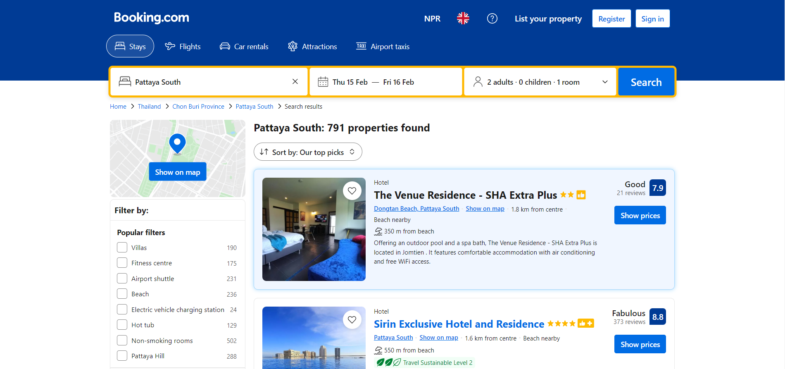

Figure 1 Booking.com Similar Website

Booking.com platforms typically offer various features to help users search for Booking Venue, Ticket for flights or to rent car. Here are some common features:

* **Search Filters:** Users have the option to refine their search by specifying criteria such as their desired location, the duration of their stay at the venue, and the number of people accompanying them.
* **Description of venue:** Detailed Description for each venue, including photos, Rating and information about their personality, hospitality and history.
* **Location-Based Search:** Users can find Venue in their local area or specify a preferred location.
* **User Accounts:** By creating accounts, users can save their favorite venues and track the expenses associated with their plans. Additionally, they can receive personalized recommendations based on their preferences.
* **Reviews and Ratings:** Some platforms incorporate reviews or ratings for venues regarding their hospitality services and user experience.
* **Integration with Social Media:** Sharing Venue on social media helps increase visibility and the chances of finding suitable adopters.

These features collectively contribute to creating a user-friendly and effective platform for finding best venue.

* Eventective

Eventective is an online booking platform for wedding venues, concert tickets, and other parties. Its primary aim is to enable users to book venues and tickets based on their preferred locations. In addition to venue booking, Eventective also assists in booking tickets for various music festivals across different locations and provides a separate category for booking peaceful places for business meetings. With its user-friendly interface, Eventective simplifies the process for users to explore and find the perfect location for their event.

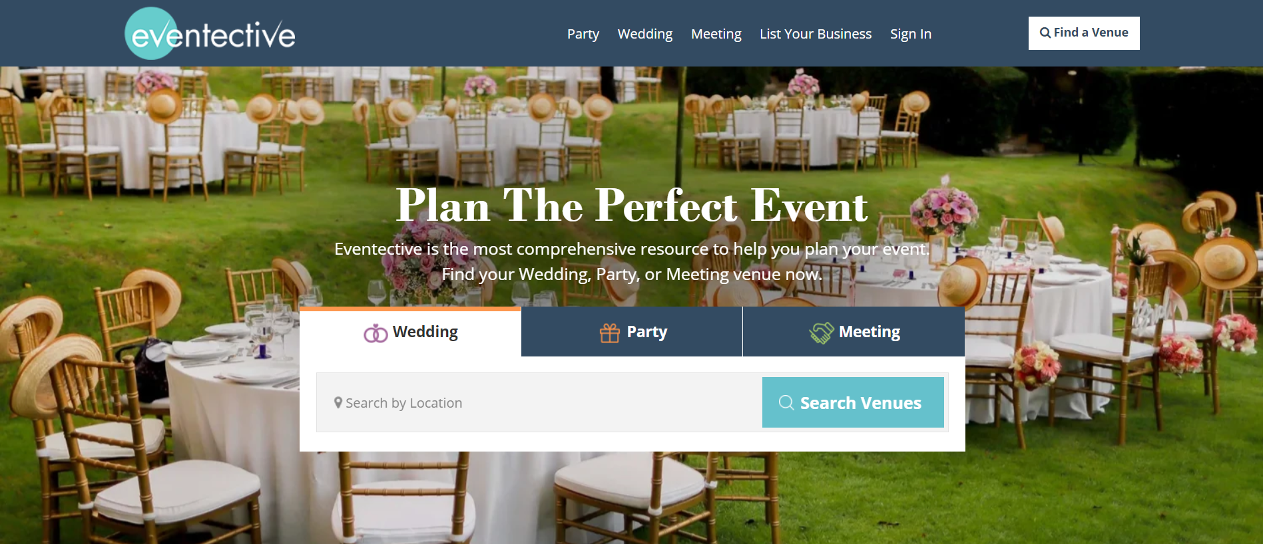

Figure 2 Eventective similar website

Booking.com platforms typically offer various features to help users search for Booking Venue, Ticket for flights or to rent car. Here are some common features:

* **Search Filters:** Users have the option to refine their search by specifying criteria such as their desired location, the duration of their stay at the venue, and the number of people accompanying them.
* **Description of venue:** Detailed Description for each venue, including photos, Rating and information about their personality, hospitality and history.
* **Location-Based Search:** Users can find Venue in their local area or specify a preferred location.
* **Booking Process Information:** Guidance for booking process,

1. Search a location
2. Get connected
3. Book an event.

* **User Accounts:** By creating accounts, users can save their favorite venues and track the expenses associated with their plans. Additionally, they can receive personalized recommendations based on their preferences.
* **Reviews and Ratings:** Some platforms incorporate reviews or ratings for venues regarding their hospitality services and user experience.
* **Integration with Social Media:** Sharing Venue on social media helps increase visibility and the chances of finding suitable adopters.

These features collectively contribute to creating a user-friendly and effective platform for finding best venue.

# Project Development

## Requirement Gathering

The requirements for Bash booker were gathered by talking to people, conducting surveys, and observing how things work. We make a contact with many people of different region that they are facing problem on booking venue of their desired location by sitting in their areas. Additionally, we examined other website to identify strengths and areas for improvement. We observed other web site how the other website used to manage the online booking. Ensuring that our site complies with regulations and utilizing the right technology were our top priorities. We determined the most important features based on user preferences and extensively tested the site to ensure ease of use.

## Use Case Diagram

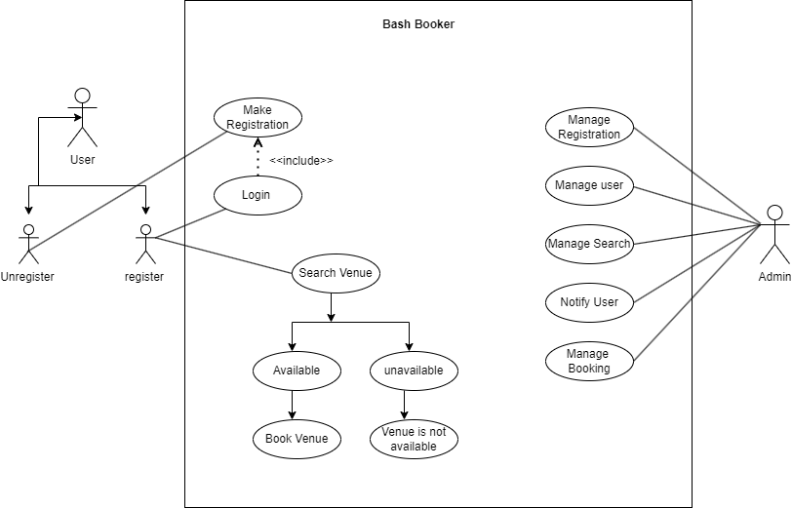

Figure 3 Use Case Diagram of Bash Booker

## SRS Document

### Introduction

#### Purpose

This Software Requirements Specification (SRS) document acts as a roadmap for the development of "Bash Booker," an online venue booking system. It defines the objectives of the system and guides the development process to ensure its successful implementation.

#### Intended Audience

This document is intended for developers, project managers, and stakeholders involved in the development and implementation of the "Bash Booker" system. It is written in a clear and concise manner to facilitate understanding for all parties involved.

#### Intended Use

"Bash Booker" is designed to simplify the process of booking venues for various events. It aims to provide users with a user-friendly platform that enables them to search, compare, and book venues according to their preferences and requirements.

#### Product Scope

The scope of "Bash Booker" encompasses a comprehensive solution for venue booking. It includes features for users to search for venues, view detailed information, make bookings, and manage bookings. Additionally, the system will provide administrative features for venue owners to manage their listings and for administrators to oversee the platform's operation.

### Overall Description

#### User Needs

Understanding user needs is crucial for the success of "Bash Booker." Users seek a straightforward and efficient platform for booking venues for their events. They expect a seamless booking process and access to detailed information about venues to make informed decisions.

#### Assumptions and Dependencies

"Bash Booker" assumes that users have access to internet-enabled devices for accessing the platform. The system does not require a secure online payment system as bookings are typically made through other means. However, the system is dependent on a stable hosting environment to ensure uninterrupted service. Regular updates and maintenance are essential to address any issues and improve the system's functionality over time.

This SRS document provides an overview of the objectives, audience, intended use, scope, user needs, assumptions, and dependencies of the "Bash Booker" project.

## System Features and Requirements

### Functional Requirements

* User Registration and Authentication

Users must be able to register for an account on the "Bash Booker" platform to access its features. Additionally, the system should provide secure authentication mechanisms to ensure user privacy and data security.

* Venue Search and Booking

The core functionality of "Bash Booker" is to enable users to search for venues based on their preferences and book them for their events.

* User Profile Management

Users should have the ability to manage their profiles on the "Bash Booker" platform, including updating their information and viewing their booking history.

* Administrative Tools

Administrators should have access to tools for managing venues, bookings, and user accounts on the "Bash Booker" platform.

## Nonfunctional Requirements

* Response Time

The system should respond to user interactions within 2 seconds on average to ensure a smooth and responsive user experience.

* Scalability

The platform should be able to handle a minimum of 100 concurrent users without experiencing significant degradation in performance.

It should also be scalable to accommodate future growth in user traffic and data volume.

* Availability

The system should have an uptime of at least 99.9% to ensure availability for users at all times, except during scheduled maintenance periods.

* Security
* Authentication and Authorization

Secure authentication mechanisms should be implemented to verify the identity of users and prevent unauthorized access to sensitive features or data.

* User Interface

The user interface should be intuitive and user-friendly, with clear navigation and informative feedback to guide users through the booking process.

These non-functional requirements outline the performance, reliability, security, usability, and maintainability aspects of the "Bash Booker" platform, ensuring that it meets the highest standards of quality and user satisfaction.

## ERD

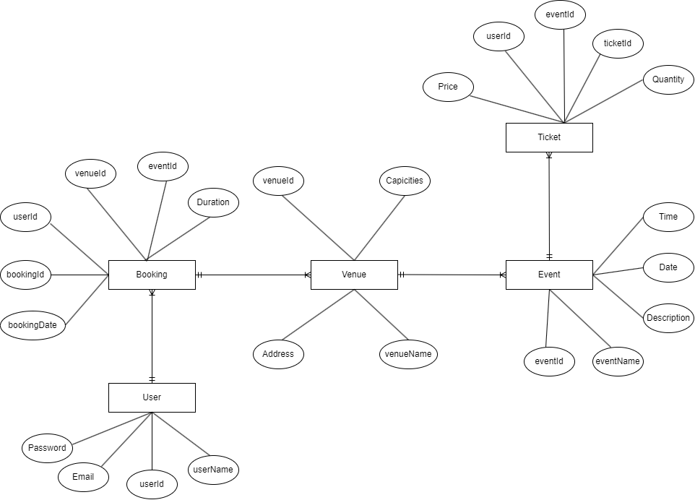

Figure 4 ERD of Bash Booker

# Analysis of progress

## Progress Table

## 

Table 1 Progress Table of Project

|  |  |  |  |
| --- | --- | --- | --- |
| S.N | Tasks | Status | Progress (%) |
| 1. | Topic Selection | Completed | 100% |
| 2. | Feasibility Study | Completed | 100% |
| 3. | Scheduling Resources | Completed | 100% |
| 4. | Cost and time estimation | Completed | 100% |
| 5. | Research on similar projects | Completed | 100% |
| 6. | Finalize Proposal | Completed | 100% |
| 7. | Conduct research and Survey | Completed | 100% |
| 8. | Design Logo for the project | Partially Completed | 50% |
| 9. | Develop Overall System Use  Case Diagram | Completed | 100% |
| 10. | Develop SRS Document | Completed | 100% |
| 11. | Develop Wireframes | Completed | 100% |
| 13. | Finalize Interim Report | Completed | 100% |
| 14. | Prepared Test Cases and  Testing | Not Completed | 0% |
| 15. | Finalize SYP Report | Not Completed | 0% |
| 16 | Review and Refinement | Not Completed | 0% |
| 17. | Submit Final Report to RTE | Not Completed | 0% |

## Gantt Chart

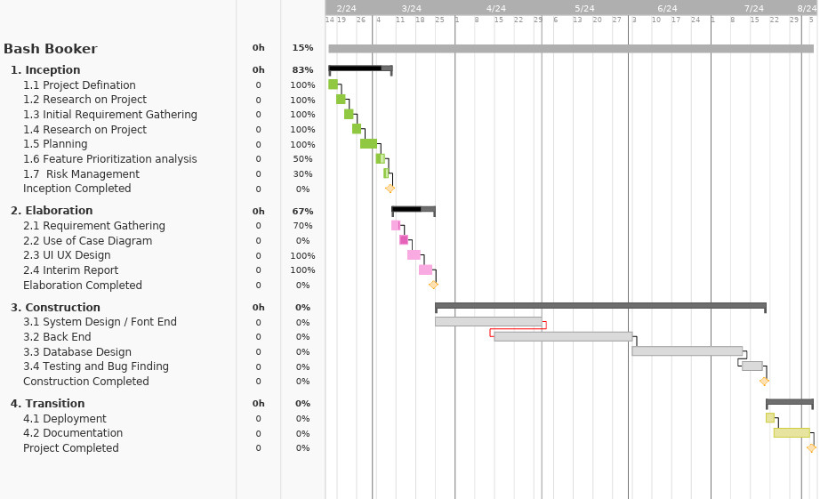

Figure 5 Gantt Chart

# Future work

Moving forward, there are several tasks outlined for completion within a specified timeframe as per the project schedule:

a) Adoption Management System Development:

This involves creating an administrative panel within the web application. Administrators will be able to manage pet listings, handle adoption inquiries, track adoption transactions, and review user feedback.

b) Test Case Preparation and Testing:

• Develop comprehensive test cases to assess the functionality, usability, and performance of the adoption management system.

• Conduct thorough testing to identify and rectify any errors or bugs within the system.

• Ensure smooth operation and adherence to project scope requirements.

c) Finalization of Second Year Project (SYP) Report:

• Complete the finalization of the SYP report, incorporating all relevant documentation and findings.

• Ensure comprehensive documentation of project objectives, methodologies, results, and conclusions.

• Review and refine the report for clarity, coherence, and quality.

d) Project Review and Refinement:

• Gather feedback from supervisors and users to pinpoint areas for improvement.

• Implement necessary refinements and modifications to enhance project effectiveness and usability.

• Ensure alignment with best practices and address any concerns or suggestions raised during the review process.

e) Submission of Final Report:

• Prepare and submit the final project report to the designated authority within the specified deadline.

• Organize and present all required documentation, including the final report and supporting materials, according to guidelines.

# References

Herbert, D. (2023, 11 23). *React Js*. Retrieved from HubSpot: https://blog.hubspot.com/website/react-js

Indeed Editor Team. (2023, 02 04). *RUP: Definition, Phases, Advantages and Best Practices*. Retrieved from Indeed: https://www.indeed.com/career-advice/career-development/rup

Moore, L. (2022, 01 23). *Mysql*. Retrieved from Tech Target: https://www.techtarget.com/searchcio/MulticloudbyDesign/Modernizing-Microsoft-SQL-Server-with-a-Multicloud-By-Design-Approach

Ozanich, A. (2022, june 06). *Javascript*. Retrieved from Hubspot: https://blog.hubspot.com/website/what-is-javascript

Zebra, T. (2023, 07 11). *Pet Adoption Statistics*. Retrieved from The Zebra: https://www.thezebra.com/resources/research/pet-adoption-statistics/

# **Appendix**

## Wireframes

### Landing Page Before Login Or register

Welcome to Bash Booker landing page, designed to extend a warm invitation to all visitors. Explore our range of offerings and services, crafted to bring joy and delight to you and your furry companions.

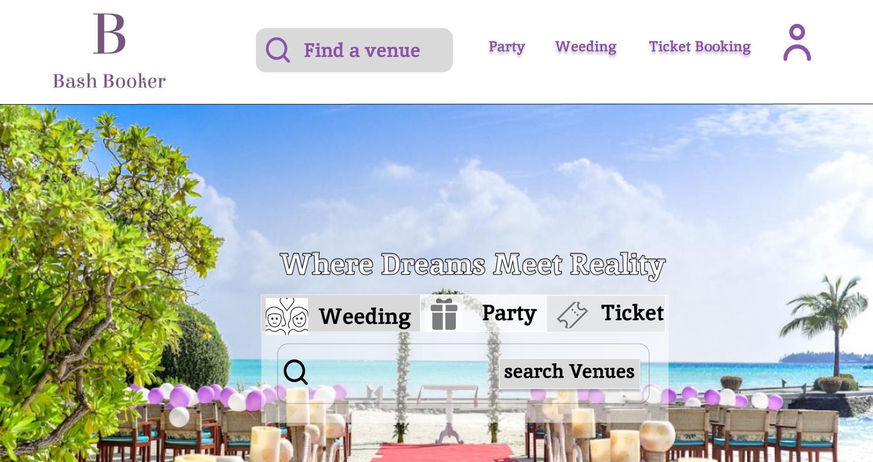

Figure 6 Landing Page

### Sign in Page

Through this page, new users can enroll on our website, gaining access to exclusive features and benefits. Any previously used email addresses for signing in are not valid. Rest assured, we have implemented stringent security measures to safeguard your information and ensure a safe browsing experience.

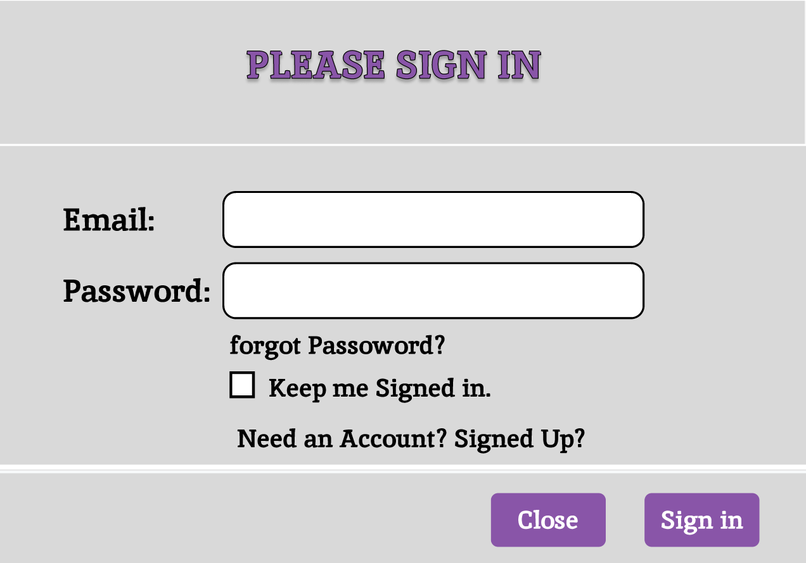

Figure 7 Sign In Page

### Party Venue

This page is for user to find the Venue for the Party as per the User desired place.

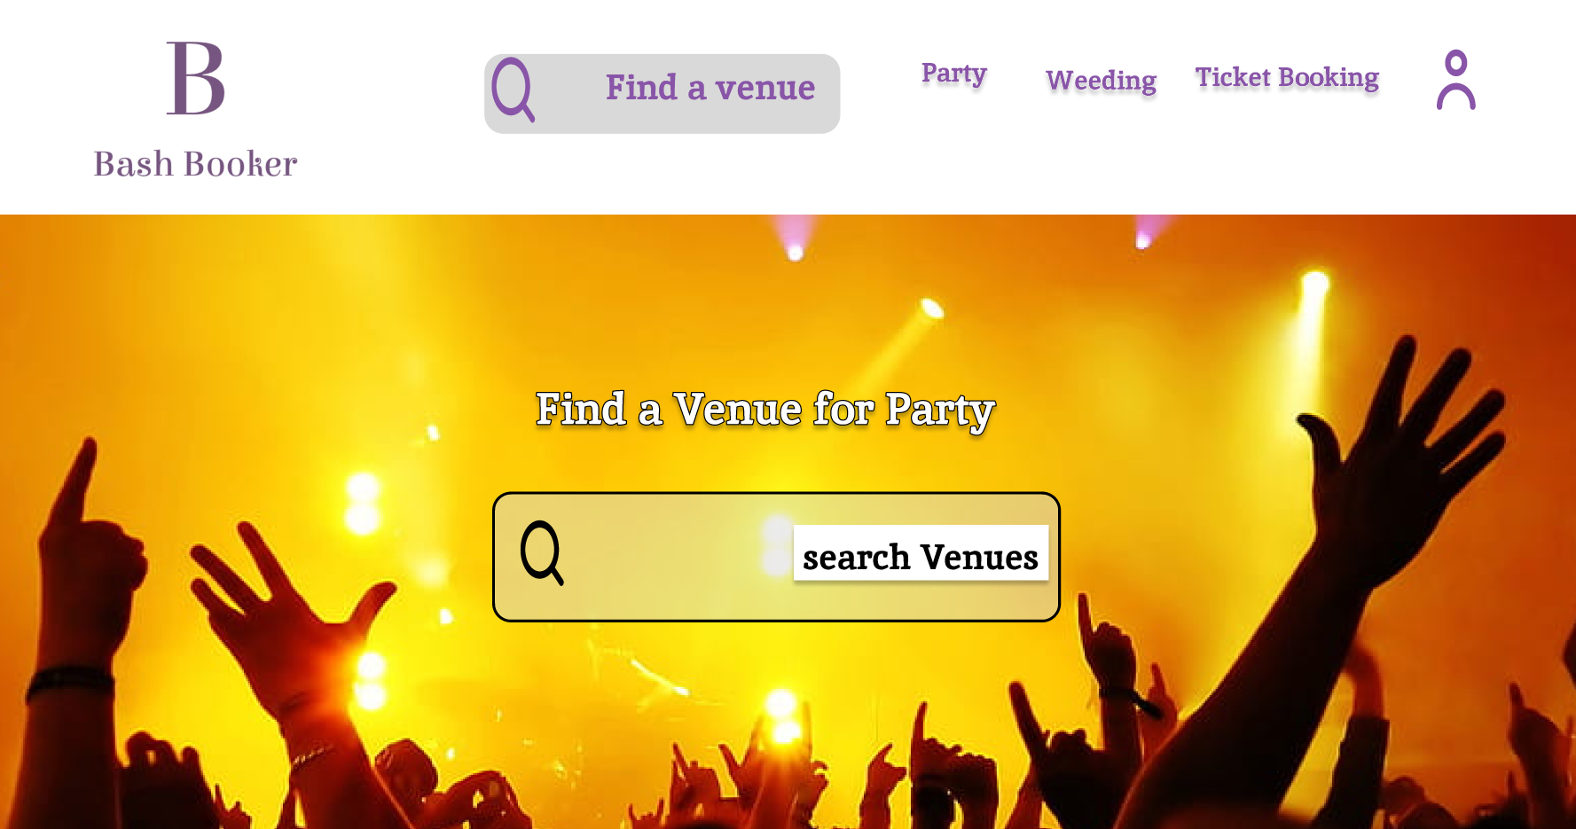

Figure 8 Party page

### Ticket Booking

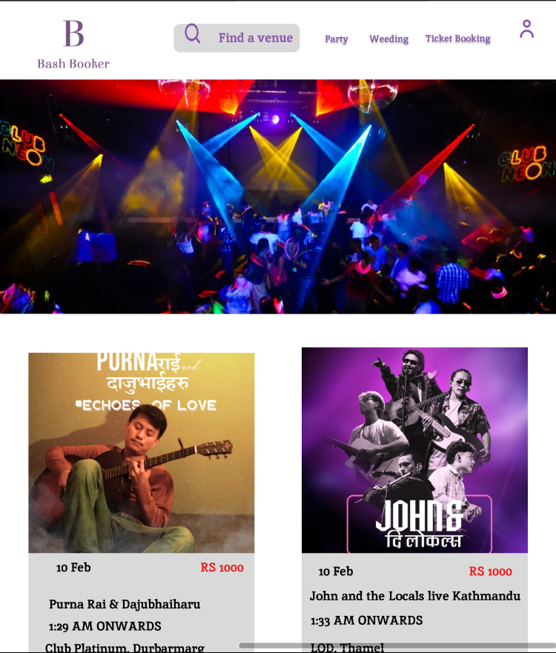

Figure 9 ticket Booking Page

### Wedding Venue Booking

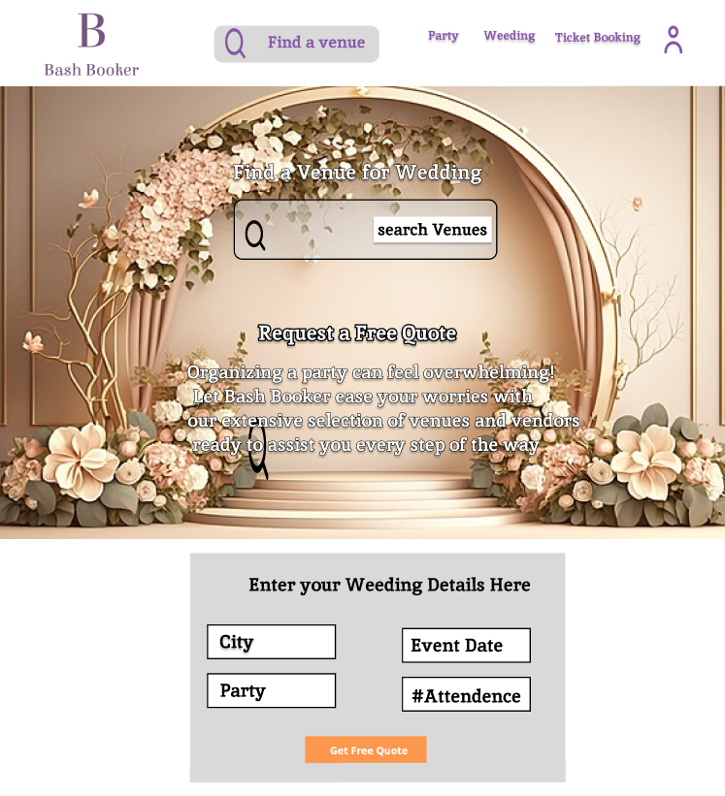

Figure 10 Wedding Venue Booking Page

## Problem Statement and Project as a solution

### Problem Statement:

The process of finding and booking venues for events can be complex and inefficient, leading to challenges for both event organizers and venue owners. Currently, there is a lack of a centralized and user-friendly platform that streamlines the venue booking process, resulting in wasted time and resources for users and venue providers alike. We need a solution that simplifies the venue booking experience, aggregates all relevant venue information into one accessible platform, and ensures seamless communication and coordination between event organizers and venue owners.

### Project as A solution

**User Interface:**

Develop a user-friendly website or mobile application where users can search for venues, view details, and make bookings.

Use modern UI frameworks such as React.js or Vue.js for frontend development to create a responsive and interactive user experience.

Design intuitive user interfaces with clear navigation and informative content to guide users through the booking process.

**Backend System:**

Implement a robust backend system to handle user authentication, venue management, booking requests, and other business logic.

Use Node.js or Django for backend development to build scalable and efficient server-side applications.

Design RESTful APIs to facilitate communication between the frontend and backend components, enabling seamless data exchange.

**Database:**

Choose a suitable database management system (DBMS) such as PostgreSQL or MongoDB to store venue information, user data, and booking details.

Design and implement database schemas to efficiently store and retrieve data, ensuring data integrity and scalability.

**Booking System:**

Develop a booking system that allows users to search for venues based on location, capacity, availability, and other criteria.

Implement features for users to view venue details, check availability, and make reservations securely.

Include functionality for venue owners to manage their listings, update availability, and communicate with users.

**Additional Features:**

Consider incorporating additional features such as user reviews and ratings, payment processing, event management tools, and integration with third-party services.

Implement security measures such as encryption, authentication, and authorization to protect user data and ensure secure transactions.

Use testing frameworks like Jest or Pytest to perform automated testing and ensure the reliability and stability of the application.

**Deployment:**

Deploy the application to a reliable hosting environment such as AWS, Google Cloud Platform, or Heroku for scalability and availability.

Configure continuous integration and continuous deployment (CI/CD) pipelines to automate the deployment process and streamline updates.